**Project 2 Proposal**

**Goal**

Analyze the pattern of and demographic characteristics of immigration in the US

**Main questions of interest**

1. Where do immigrants originate from and in which States do they settle?
2. What are the age, gender, workforce, Income and educational characteristics of immigrants?

**Expected Deliverables**

**The aspiration is to make the following graphs/charts/maps**

1. Heatmap
2. Bubble chart
3. Pie charts
4. Pyramid charts

**Approach**

Build a heatmap and bubble charts of authorized and unauthorized immigration from around the world to the US by State:

1. Build dropdown menu that allows for selection of “
2. Countries of origin
3. authorized” and “unauthorized
4. Build a “select button” for a couple of demographic factors to display visual profiles of immigrations :
5. education attainment
6. income
7. Build bubbles that will appear over states of destination, sized according to the estimated emigrant population in each State.

The heatmap will display background information of immigration totals in each State

By selecting “authorized or unauthorized and a demographic indicator will display bubbles over countries of origin fand the selected demographic profile of the immigrant population of a selected country in a State.

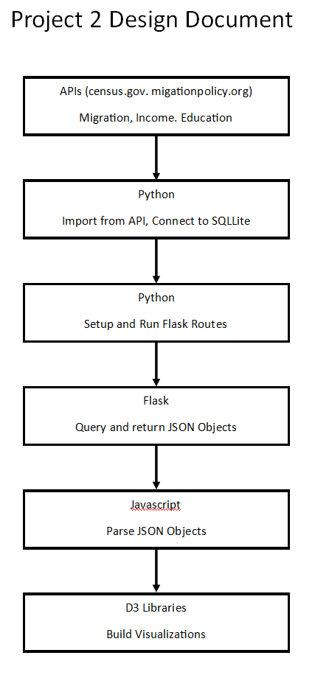

Sample of map we may seek to produce

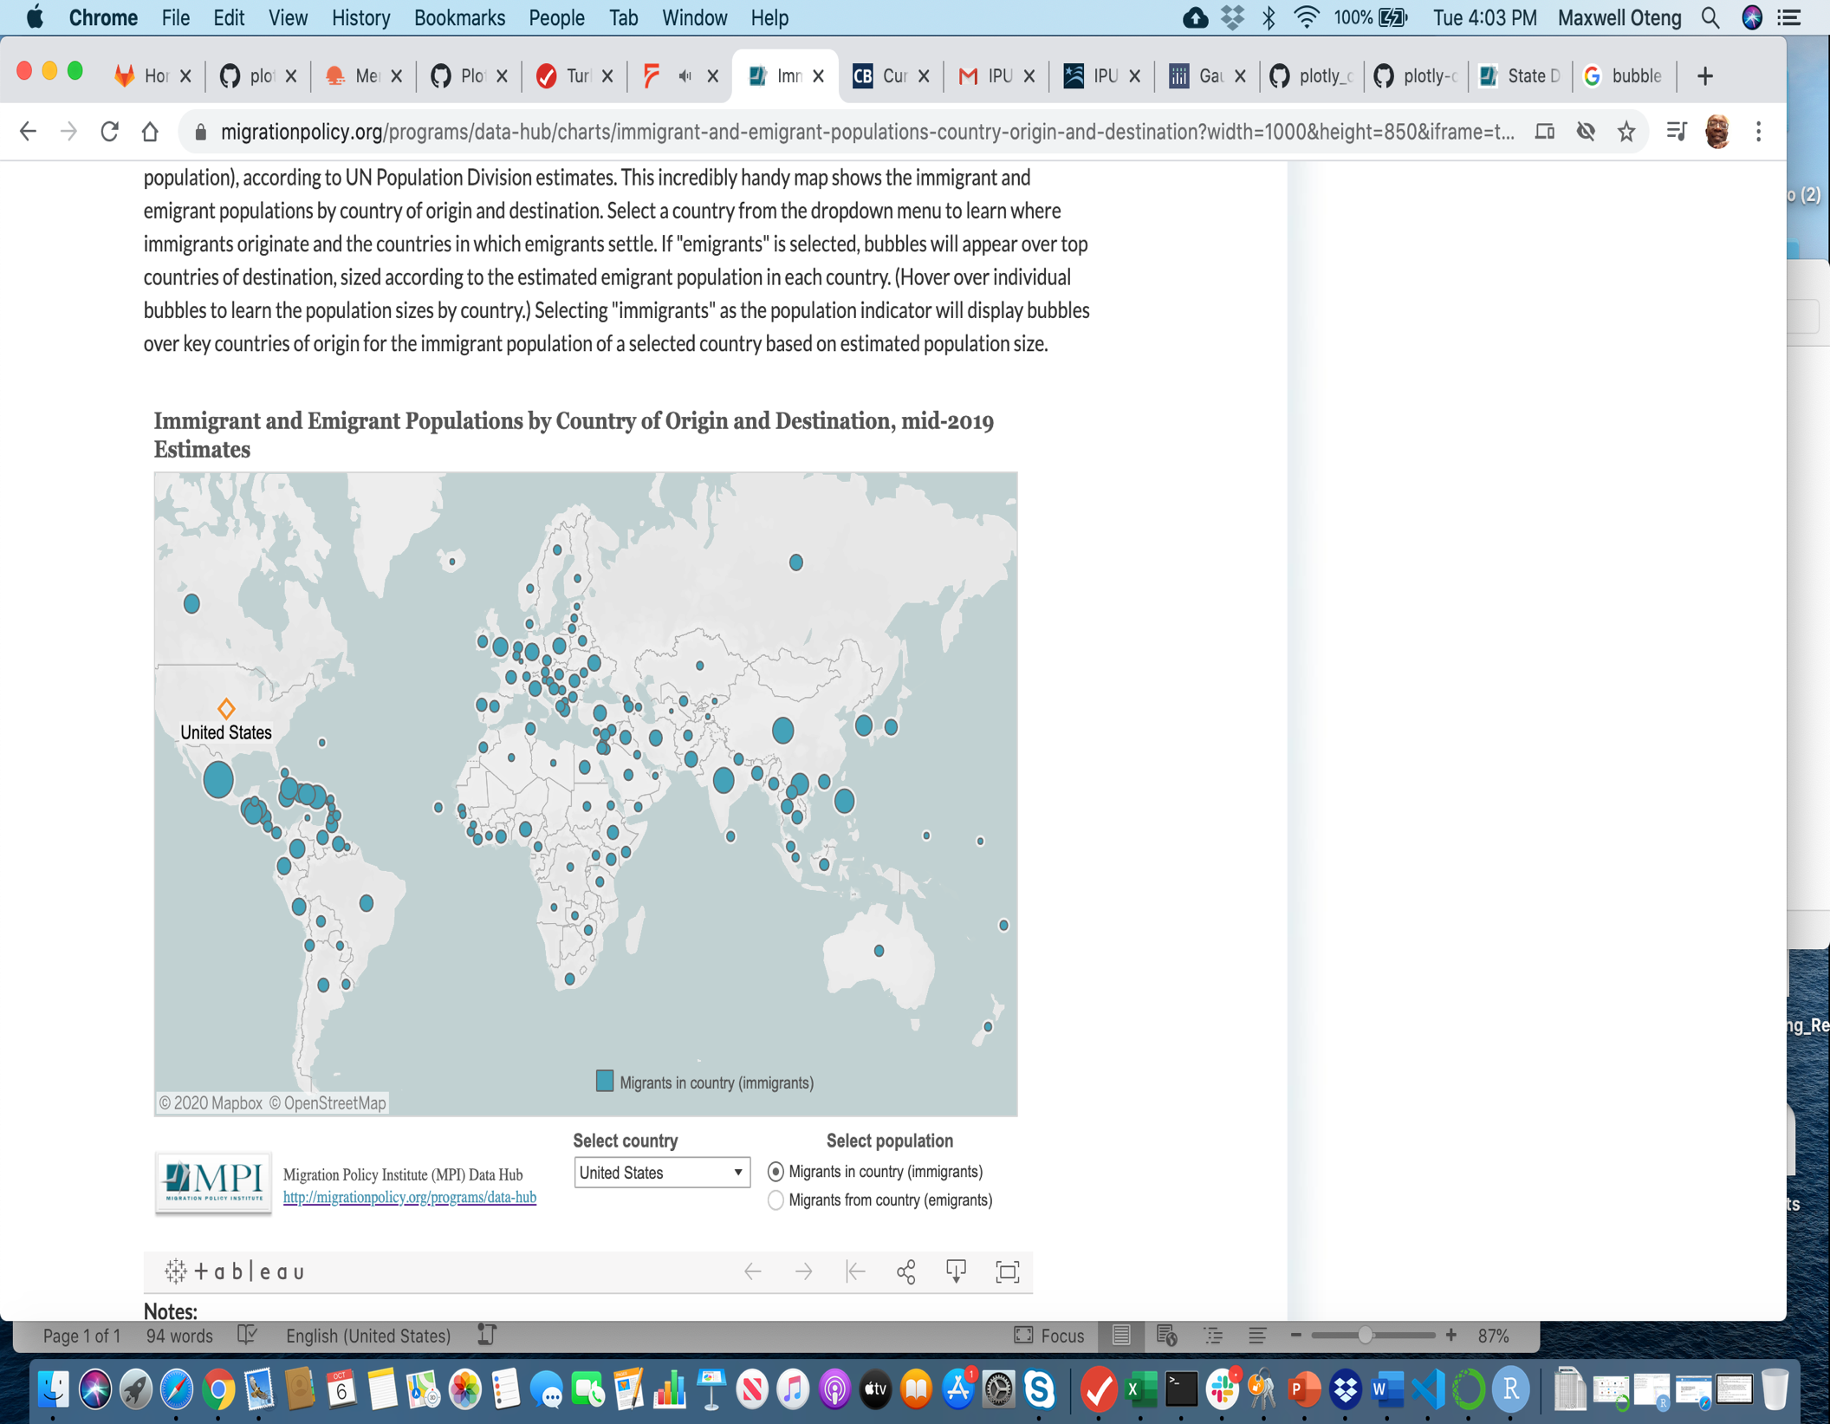

**Data Sources**

<https://www.migrationpolicy.org/data/state-profiles/state/income/US//>

<https://www.migrationpolicy.org/programs/us-immigration-policy-program-data-hub/unauthorized-immigrant-population-profiles>

<https://data.census.gov/cedsci/table?q=immigration&tid=ACSST1Y2019.S0502&hidePreview=true>

<https://www.dhs.gov/immigration-statistics>

<https://www.census.gov/topics/population/foreign-born.html>

<https://usa.ipums.org/usa/>

<https://www.pewresearch.org/fact-tank/2020/08/20/key-findings-about-u-s-immigrants/> (this shows data sources used by Pew Research for its immigration analyses.